RHYTHM and MELODY BANK
- Rhythmic Patterns

- Western notations are not supposed to be presented to students. The notations are given to provide teachers appropriate rhythmic and melodic syllables. These syllables should be taught by rote singing.
Gan  Gan  Gan | Gan  Gan  Gan ji
Gan ji  Gan ji  Gan | Gan  Gan ji  Gan ji
Gan ji  Gan ji  Gan ji | Ge Gan  Gan ji  Ge ge ge
Gan ji  Gan ji  Ge Gan | Gan ji  Ge ge ge  Gan ji
Gan ji  Ge Gan  Gan ji | Gan  Gan ji  Ge Gan
Gan ji  Ge Gan  Gan  Gan | Gan ji  Ge ge ge  Gan

- Melodic Patterns

- Western notations are not supposed to be presented to students. The notations are given to provide teachers appropriate rhythmic and melodic syllables. These syllables should be taught by rote singing.
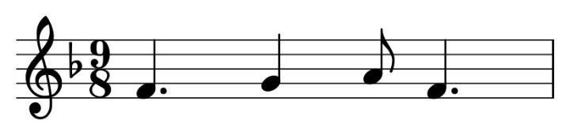 | 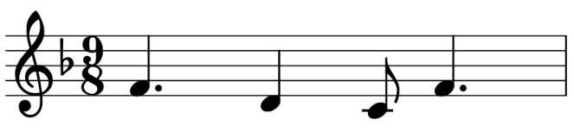
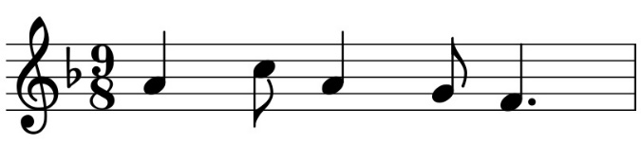 | 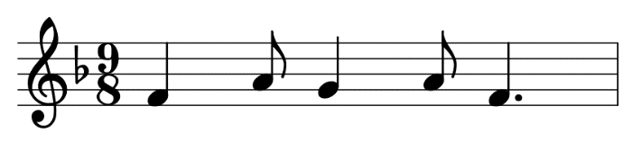
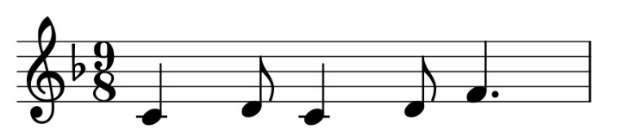 | 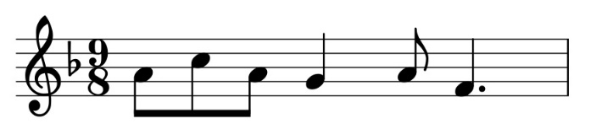
 | 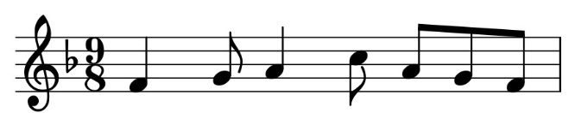
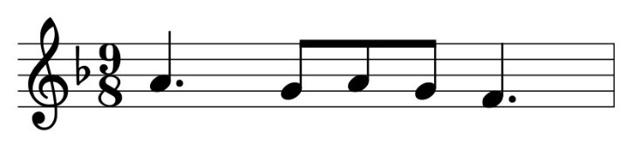 | 